Shubham Rawat

MCA 2020 -2021

**Java Assignment 5**

Q30. WAP to create a class Student with private data members as roll_no, name, age, marks in 3 subjects, define a function to calculate the total marks of students, define a function to display all the details of student. Create two student objects and initialize one object with default and other with parameterized constructor.

class Student{

private int roll_no;

private String name;

private int age;

private float mark1,mark2,mark3,result;

Student(){ // default constructor

roll_no = 101;

name = "xyz";

age = 18;

mark1 = 45;

mark2 = 45;

mark3 = 45;

}

Student(int rollno, String sname, int sage, float m1, float m2, float m3){ // parameterized constructor

roll_no = rollno;

name = sname;

age = sage;

mark1 = m1;

mark2 = m2;

mark3 = m3;

}

void totalMarks(){

result = (mark1+mark2+mark3)/3;

}

void display(){

System.out.println("Roll no : "+roll_no);

System.out.println("Name : "+name);

System.out.println("Age : "+age);

System.out.println("marks 1 : "+mark1);

System.out.println("marks 2 : "+mark2);

System.out.println("marks 3 : "+mark3);

System.out.println("Total marks: "+result);

}

public static void main(String args[]){

Student s1 = new Student();

Student s2 = new Student(100,"abc",20,65.5f,65.5f,65.5f);

s1.totalMarks();

s2.totalMarks();

s1.display();

s2.display();

}

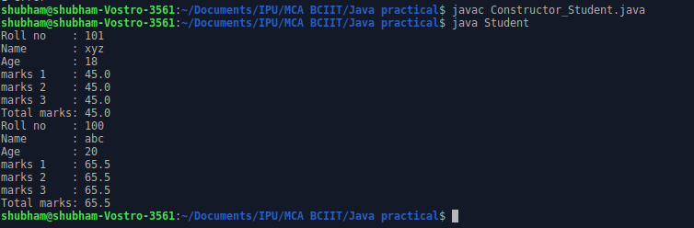

Q31. Write a program to create a class Test1 in package pack1 and define method checkarmstrong() to check a no is armstrong or not and create class Test2 in package pack2 and invoke checkarmstrong() from Test2 class.

package pack1;

public class Test1{

public void Checkarmstrong(int n){

int sum = 0;

int res = n,a;

while(n>0){

a=n%10;

sum = sum + a*a*a;

n=n/10;

}

if(res==sum)

System.out.println(sum+" it is armstrong");

else

System.out.println(sum+" it not is armstrong");

}

}

package pack2;

import pack1.Test1;

import java.util.Scanner;

class Test2{

public static void main(String args[]){

Scanner O = new Scanner(System.in);

System.out.print("\n Enter a no. : ");

int a = O.nextInt();

Test1 b = new Test1();

b.Checkarmstrong(a);

}

}

